**Human Age Estimation and Gender Detection using Deep Learning**

**ABSTRACT**

A Human Age Estimation and Gender Detection system employs deep learning techniques to estimate the age and detect the gender of individuals from images or videos. By training on diverse datasets, the system's neural networks learn to analyze facial features, textures, and patterns to predict age and determine gender. This technology has applications in demographics analysis, targeted advertising, security systems, and social research, providing valuable insights into user profiles and enabling personalized interactions based on age and gender demographics.

**Requirements:**

The various requirements of the module in the process of recognition of age, gender include:

• The training of the networks requires the latest, large and different types of datasets.

• Training requires high power in computation due to the large size of the dataset and high number of parameters for the CNN models.

• The post deployment results will be near real time only, due to the low FPS from the webcams.

**Setup for implementation:**

• OpenCV (Used for taking input from webcam)

• Python

• Media pipe

• NumPy

• TensorFlow

**EXISTING SYSTEM**

The existing traditional face recognition systems can be categorised into two categories: holistic features and local feature approaches. The holistic group can be additionally divided into linear and nonlinear projection methods. Many applications have shown good results of the linear projection appearance‐based methods such as principal component analysis (PCA), independent component analysis (ICA), linear discriminate analysis (LDA), 2DPCA and linear regression classifier (LRC).

**Disadvantages:**

* However, due to large variations in illumination conditions, facial expression and other factors, these methods may fail to adequately represent the faces.
* The main reason is that the face patterns lie on a complex nonlinear and non‐convex manifold in the high‐dimensional space.
* These methods may fail to adequately represent faces when large variations in illumination facial expressions and other factors occur.

**Proposed system:**

In proposed system, artificial neural networks are used to solve nonlinear problem. Using different models to get the different face attributes, such as media pipe, open cv, tensor-flow and CNN & DNN models

**Advantages:**

* Artificial neural network is naturally integrated with non‐negative matrix factorisation.
* The main advantage of the approach is possibility of employing redundancy present in video to improve still image systems.

**Future Work:**

For future model we can improve the accuracy by trying other different techniques & different machine learning algorithms and other different approaches to detect multiple faces at one time.

We can also try to evaluate the different other facial attributes.

**Introduction:**

Recognition of the face as an identity is a critical aspect in today’s world. Facial identification and recognition find its use in many real-life contexts, whether your identity card, passport, or any other credential of significant importance. It has become quite a popular tool these days to authenticate the identity of an individual. This technology is also being used in various sectors and industries to prevent ID fraud and identity theft. Your smartphone also has a face recognition feature to unlock it. The recognition incorporated in such tasks demands three things: the ability to comprehend identity from unfamiliar faces, the ability to learn new faces, and the ability to acknowledge familiar faces. Although the concept of facial recognition is not new, technological advancements over the years have led to a massive expansion of this technology.

## **How Facial Recognition works?**

The process of facial recognition starts with the human face and identifying its necessary facial features and patterns. A human face comprises a very basic set of features, such as eyes, nose, and mouth. Facial recognition technology learns what a face is and how it looks. This is done by using deep neural network & machine learning algorithms on a set of images with human faces looking at different angles or positions.

The process starts with detecting the human eyes, one of the most accessible features to detect, and then proceeds to detect eyebrows, nose, mouth, etc. Calculating the width of the nose, the distance between the eyes, and the shape & size of the mouth, the model created tries to find insights from the facial region. Multiple algorithm training can be performed to improve the algorithm’s accuracy to detect the faces and their positions. Once the face is detected, the model is then trained further with the help of computer vision algorithms to detect the facial landmark features such as eyebrow corners, eyes gap, the tip of the nose, mouth corners, etc. Each feature is considered as a nodal point, and each face consists of around 80 nodal points. These landmark features are the key to distinguish each face present in the database.

After the facial features are extracted, landmarks, face position, orientation & all key elements are fed into the model; the model generates a unique feature vector for each face in its numeric form. A unique code generated identifies the person among all the others in the dataset. The generated feature vector is then used to search and match from the entire dataset or database of faces present during the face detection process.

**METHODS:**

Following Methods and Techniques were used in the Project.

* Importing all the necessary models
* Downloading all the necessary pre-trained models
* Media pipe
* Open cv
* Tensor-flow
* CNN
* DNN

Details of the above Methods are mentioned below in the document

**Expected Models to be used:**

* Media pipe
* Open cv
* Tensor-flow
* CNN
* DNN

**MEDIAPIPE**

Since 2012, Google has been using Mediapipe internally in several products and services. It was initially developed for real-time analysis of video and audio on YouTube. Gradually it got integrated into many more products, such as

Perception system in NestCam

Object detection by Google Lens

Augmented Reality Ads

Google Photos

Google Home

Gmail

Cloud Vision API, etc.

MediaPipe powers revolutionary products and services we use daily. Unlike power-hungry machine learning Frameworks, MediaPipe requires minimal resources. It is so tiny and efficient that even embedded IoT devices can run it. In 2019, MediaPipe opened up a whole new world of opportunity for researchers and developers following its public release.

MediaPipe is a Framework for building machine learning pipelines for processing time-series data like video, audio, etc. This cross-platform Framework works in Desktop/Server, Android, iOS, and embedded devices like Raspberry Pi and Jetson Nano.

**Graphs**

The MediaPipe perception pipeline is called a **Graph**. Let us take the example of the first solution, Hands. We feed a stream of images as input which comes out with hand landmarks rendered on the images.



The flow chart below represents the MP (Abbr. MediaPipe) hand solution graph.



In computer science, a graph consists of Nodes connected by Edges. Inside the MediaPipe Graph, the nodes are called **Calculators**, and edges are called **Streams**. Every stream carries a sequence of **Packets**that have ascending time stamps.

In the image above, we have represented Calculators with rectangular blocks and Streams using arrows.

# MediaPipe Hands

The ability to perceive the shape and motion of hands can be a vital component in improving the user experience across a variety of technological domains and platforms. For example, it can form the basis for sign language understanding and hand gesture control, and can also enable the overlay of digital content and information on top of the physical world in augmented reality. While coming naturally to people, robust real-time hand perception is a decidedly challenging computer vision task, as hands often occlude themselves or each other (e.g. finger/palm occlusions and hand shakes) and lack high contrast patterns.

MediaPipe Hands is a high-fidelity hand and finger tracking solution. It employs machine learning (ML) to infer 21 3D landmarks of a hand from just a single frame. Whereas current state-of-the-art approaches rely primarily on powerful desktop environments for inference, our method achieves real-time performance on a mobile phone, and even scales to multiple hands. We hope that providing this hand perception functionality to the wider research and development community will result in an emergence of creative use cases, stimulating new applications and new research avenues.

## **ML Pipeline**

MediaPipe Hands utilizes an ML pipeline consisting of multiple models working together: A palm detection model that operates on the full image and returns an oriented hand bounding box. A hand landmark model that operates on the cropped image region defined by the palm detector and returns high-fidelity 3D hand keypoints. This strategy is similar to that employed in our MediaPipe Face Mesh solution, which uses a face detector together with a face landmark model.

Providing the accurately cropped hand image to the hand landmark model drastically reduces the need for data augmentation (e.g. rotations, translation and scale) and instead allows the network to dedicate most of its capacity towards coordinate prediction accuracy. In addition, in our pipeline the crops can also be generated based on the hand landmarks identified in the previous frame, and only when the landmark model could no longer identify hand presence is palm detection invoked to relocalize the hand.

The pipeline is implemented as a MediaPipe graph that uses a hand landmark tracking subgraph from the hand landmark module, and renders using a dedicated hand renderer subgraph. The hand landmark tracking subgraph internally uses a hand landmark subgraph from the same module and a palm detection subgraph from the palm detection module.

## **Models**

### **Palm Detection Model**

To detect initial hand locations, we designed a single-shot detector model optimized for mobile real-time uses in a manner similar to the face detection model in MediaPipe Face Mesh. Detecting hands is a decidedly complex task: our lite model and full model have to work across a variety of hand sizes with a large scale span (~20x) relative to the image frame and be able to detect occluded and self-occluded hands. Whereas faces have high contrast patterns, e.g., in the eye and mouth region, the lack of such features in hands makes it comparatively difficult to detect them reliably from their visual features alone. Instead, providing additional context, like arm, body, or person features, aids accurate hand localization.

Our method addresses the above challenges using different strategies. First, we train a palm detector instead of a hand detector, since estimating bounding boxes of rigid objects like palms and fists is significantly simpler than detecting hands with articulated fingers. In addition, as palms are smaller objects, the non-maximum suppression algorithm works well even for two-hand self-occlusion cases, like handshakes. Moreover, palms can be modelled using square bounding boxes (anchors in ML terminology) ignoring other aspect ratios, and therefore reducing the number of anchors by a factor of 3-5. Second, an encoder-decoder feature extractor is used for bigger scene context awareness even for small objects (similar to the RetinaNet approach). Lastly, we minimize the focal loss during training to support a large amount of anchors resulting from the high scale variance.

With the above techniques, we achieve an average precision of 95.7% in palm detection. Using a regular cross entropy loss and no decoder gives a baseline of just 86.22%.

### **Hand Landmark Model**

After the palm detection over the whole image our subsequent hand landmark model performs precise keypoint localization of 21 3D hand-knuckle coordinates inside the detected hand regions via regression, that is direct coordinate prediction. The model learns a consistent internal hand pose representation and is robust even to partially visible hands and self-occlusions.

To obtain ground truth data, we have manually annotated ~30K real-world images with 21 3D coordinates, as shown below (we take Z-value from image depth map, if it exists per corresponding coordinate). To better cover the possible hand poses and provide additional supervision on the nature of hand geometry, we also render a high-quality synthetic hand model over various backgrounds and map it to the corresponding 3D coordinates.

| **hand_landmarks.png** |
| --- |
| Fig 2. 21 hand landmarks. |
| **hand_crops.png** |
|  |
| Fig 3. Top: Aligned hand crops passed to the tracking network with ground truth annotation. Bottom: Rendered synthetic hand images with ground truth annotation. |

## **Solution APIs**

### **Configuration Options**

Naming style and availability may differ slightly across platforms/languages.

#### STATIC\_IMAGE\_MODE

If set to false, the solution treats the input images as a video stream. It will try to detect hands in the first input images, and upon a successful detection further localizes the hand landmarks. In subsequent images, once all [max\_num\_hands](https://google.github.io/mediapipe/solutions/hands.html" \l "max_num_hands) hands are detected and the corresponding hand landmarks are localized, it simply tracks those landmarks without invoking another detection until it loses track of any of the hands. This reduces latency and is ideal for processing video frames. If set to true, hand detection runs on every input image, ideal for processing a batch of static, possibly unrelated, images. Default to false.

#### MAX\_NUM\_HANDS

Maximum number of hands to detect. Default to 2.

#### MODEL\_COMPLEXITY

Complexity of the hand landmark model: 0 or 1. Landmark accuracy as well as inference latency generally go up with the model complexity. Default to 1.

#### MIN\_DETECTION\_CONFIDENCE

Minimum confidence value ([0.0, 1.0]) from the hand detection model for the detection to be considered successful. Default to 0.5.

#### MIN\_TRACKING\_CONFIDENCE:

Minimum confidence value ([0.0, 1.0]) from the landmark-tracking model for the hand landmarks to be considered tracked successfully, or otherwise hand detection will be invoked automatically on the next input image. Setting it to a higher value can increase robustness of the solution, at the expense of a higher latency. Ignored if [static\_image\_mode](https://google.github.io/mediapipe/solutions/hands.html" \l "static_image_mode) is true, where hand detection simply runs on every image. Default to 0.5.

### **Output**

Naming style may differ slightly across platforms/languages.

#### MULTI\_HAND\_LANDMARKS

Collection of detected/tracked hands, where each hand is represented as a list of 21 hand landmarks and each landmark is composed of x, y and z. x and y are normalized to [0.0, 1.0] by the image width and height respectively. z represents the landmark depth with the depth at the wrist being the origin, and the smaller the value the closer the landmark is to the camera. The magnitude of z uses roughly the same scale as x.

#### MULTI\_HAND\_WORLD\_LANDMARKS

Collection of detected/tracked hands, where each hand is represented as a list of 21 hand landmarks in world coordinates. Each landmark is composed of x, y and z: real-world 3D coordinates in meters with the origin at the hand’s approximate geometric center.

#### MULTI\_HANDEDNESS

Collection of handedness of the detected/tracked hands (i.e. is it a left or right hand). Each hand is composed of label and score. label is a string of value either "Left" or "Right". score is the estimated probability of the predicted handedness and is always greater than or equal to 0.5 (and the opposite handedness has an estimated probability of 1 - score).

Note that handedness is determined assuming the input image is mirrored, i.e., taken with a front-facing/selfie camera with images flipped horizontally. If it is not the case, please swap the handedness output in the application.

# Opencv



OpenCV (Open Source Computer Vision Library) is released under a BSD license and hence it’s free for both academic and commercial use. It has C++, Python and Java interfaces and supports Windows, Linux, Mac OS, iOS and Android. OpenCV was designed for computational efficiency and with a strong focus on real-time applications. Written in optimized C/C++, the library can take advantage of multi-core processing. Enabled with OpenCL, it can take advantage of the hardware acceleration of the underlying heterogeneous compute platform.

OpenCV (Open Source Computer Vision Library) is an open source computer vision and machine learning software library. OpenCV was built to provide a common infrastructure for computer vision applications and to accelerate the use of machine perception in the commercial products. Being a BSD-licensed product, OpenCV makes it easy for businesses to utilize and modify the code.

The library has more than 2500 optimized algorithms, which includes a comprehensive set of both classic and state-of-the-art computer vision and machine learning algorithms. These algorithms can be used to detect and recognize faces, identify objects, classify human actions in videos, track camera movements, track moving objects, extract 3D models of objects, produce 3D point clouds from stereo cameras, stitch images together to produce a high resolution image of an entire scene, find similar images from an image database, remove red eyes from images taken using flash, follow eye movements, recognize scenery and establish markers to overlay it with augmented reality, etc. OpenCV has more than 47 thousand people of user community and estimated number of downloads exceeding 14 million. The library is used extensively in companies, research groups and by governmental bodies.

Along with well-established companies like Google, Yahoo, Microsoft, Intel, IBM, Sony, Honda, Toyota that employ the library, there are many startups such as Applied Minds, VideoSurf, and Zeitera, that make extensive use of OpenCV. OpenCV’s deployed uses span the range from stitching streetview images together, detecting intrusions in surveillance video in Israel, monitoring mine equipment in China, helping robots navigate and pick up objects at Willow Garage, detection of swimming pool drowning accidents in Europe, running interactive art in Spain and New York, checking runways for debris in Turkey, inspecting labels on products in factories around the world on to rapid face detection in Japan.

It has C++, Python, Java and MATLAB interfaces and supports Windows, Linux, Android and Mac OS. OpenCV leans mostly towards real-time vision applications and takes advantage of MMX and SSE instructions when available. A full-featured CUDAand OpenCL interfaces are being actively developed right now. There are over 500 algorithms and about 10 times as many functions that compose or support those algorithms. OpenCV is written natively in C++ and has a templated interface that works seamlessly with STL containers.

OpenCV has a modular structure, which means that the package includes several shared or static libraries. The following modules are available:

* Core functionality (core) - a compact module defining basic data structures, including the dense multi-dimensional array Mat and basic functions used by all other modules.
* Image Processing (imgproc) - an image processing module that includes linear and non-linear image filtering, geometrical image transformations (resize, affine and perspective warping, generic table-based remapping), color space conversion, histograms, and so on.
* Video Analysis (video) - a video analysis module that includes motion estimation, background subtraction, and object tracking algorithms.
* Camera Calibration and 3D Reconstruction (calib3d) - basic multiple-view geometry algorithms, single and stereo camera calibration, object pose estimation, stereo correspondence algorithms, and elements of 3D reconstruction.
* 2D Features Framework (features2d) - salient feature detectors, descriptors, and descriptor matchers.
* Object Detection (objdetect) - detection of objects and instances of the predefined classes (for example, faces, eyes, mugs, people, cars, and so on).
* High-level GUI (highgui) - an easy-to-use interface to simple UI capabilities.
* Video I/O (videoio) - an easy-to-use interface to video capturing and video codecs.
* ... some other helper modules, such as FLANN and Google test wrappers, Python bindings, and others.

OpenCV was started at Intel in 1999 by **Gary Bradsky** and the first release came out in 2000. **Vadim Pisarevsky** joined Gary Bradsky to manage Intel’s Russian software OpenCV team. In 2005, OpenCV was used on Stanley, the vehicle who won 2005 DARPA Grand Challenge. Later its active development continued under the support of Willow Garage, with Gary Bradsky and Vadim Pisarevsky leading the project. Right now, OpenCV supports a lot of algorithms related to Computer Vision and Machine Learning and it is expanding day-by-day.

Currently OpenCV supports a wide variety of programming languages like C++, Python, Java etc and is available on different platforms including Windows, Linux, OS X, Android, iOS etc. Also, interfaces based on CUDA and OpenCL are also under active development for high-speed GPU operations.

OpenCV-Python is the Python API of OpenCV. It combines the best qualities of OpenCV C++ API and Python language.

## **OpenCV-Python**

Python is a general purpose programming language started by **Guido van Rossum**, which became very popular in short time mainly because of its simplicity and code readability. It enables the programmer to express his ideas in fewer lines of code without reducing any readability.

Compared to other languages like C/C++, Python is slower. But another important feature of Python is that it can be easily extended with C/C++. This feature helps us to write computationally intensive codes in C/C++ and create a Python wrapper for it so that we can use these wrappers as Python modules. This gives us two advantages: first, our code is as fast as original C/C++ code (since it is the actual C++ code working in background) and second, it is very easy to code in Python. This is how OpenCV-Python works, it is a Python wrapper around original C++ implementation.

And the support of Numpy makes the task more easier. **Numpy** is a highly optimized library for numerical operations. It gives a MATLAB-style syntax. All the OpenCV array structures are converted to-and-from Numpy arrays. So whatever operations you can do in Numpy, you can combine it with OpenCV, which increases number of weapons in your arsenal. Besides that, several other libraries like SciPy, Matplotlib which supports Numpy can be used with this.

So OpenCV-Python is an appropriate tool for fast prototyping of computer vision problems

**Automatic Memory Management**

OpenCV handles all the memory automatically.

First of all, std::vector, cv::Mat, and other data structures used by the functions and methods have destructors that deallocate the underlying memory buffers when needed. This means that the destructors do not always deallocate the buffers as in case of Mat. They take into account possible data sharing. A destructor decrements the reference counter associated with the matrix data buffer. The buffer is deallocated if and only if the reference counter reaches zero, that is, when no other structures refer to the same buffer. Similarly, when a Mat instance is copied, no actual data is really copied. Instead, the reference counter is incremented to memorize that there is another owner of the same data. There is also the Mat::clone method that creates a full copy of the matrix data.

**Automatic Allocation of the Output Data**

OpenCV deallocates the memory automatically, as well as automatically allocates the memory for output function parameters most of the time. So, if a function has one or more input arrays (cv::Mat instances) and some output arrays, the output arrays are automatically allocated or reallocated. The size and type of the output arrays are determined from the size and type of input arrays. If needed, the functions take extra parameters that help to figure out the output array properties.

The array frame is automatically allocated by the >> operator since the video frame resolution and the bit-depth is known to the video capturing module. The array edges is automatically allocated by the cvtColor function. It has the same size and the bit-depth as the input array. The number of channels is 1 because the color conversion code cv::COLOR\_BGR2GRAY is passed, which means a color to grayscale conversion. Note that frame and edges are allocated only once during the first execution of the loop body since all the next video frames have the same resolution. If you somehow change the video resolution, the arrays are automatically reallocated.

The key component of this technology is the Mat::create method. It takes the desired array size and type. If the array already has the specified size and type, the method does nothing. Otherwise, it releases the previously allocated data, if any (this part involves decrementing the reference counter and comparing it with zero), and then allocates a new buffer of the required size. Most functions call the Mat::create method for each output array, and so the automatic output data allocation is implemented.

Some notable exceptions from this scheme are cv::mixChannels, cv::RNG::fill, and a few other functions and methods. They are not able to allocate the output array, so you have to do this in advance.

**Saturation Arithmetics**

As a computer vision library, OpenCV deals a lot with image pixels that are often encoded in a compact, 8- or 16-bit per channel, form and thus have a limited value range. Furthermore, certain operations on images, like color space conversions, brightness/contrast adjustments, sharpening, complex interpolation (bi-cubic, Lanczos) can produce values out of the available range. If you just store the lowest 8 (16) bits of the result, this results in visual artifacts and may affect a further image analysis. To solve this problem, the so-called saturation arithmetics is used. For example, to store r, the result of an operation, to an 8-bit image, you find the nearest value within the 0..255 range:

**I(x,y)=min(max(round(r),0),255)**

Similar rules are applied to 8-bit signed, 16-bit signed and unsigned types. This semantics is used everywhere in the library. In C++ code, it is done using the cv::saturate\_cast<> functions that resemble standard C++ cast operations.

**Fixed Pixel Types. Limited Use of Templates**

Templates is a great feature of C++ that enables implementation of very powerful, efficient and yet safe data structures and algorithms. However, the extensive use of templates may dramatically increase compilation time and code size. Besides, it is difficult to separate an interface and implementation when templates are used exclusively. This could be fine for basic algorithms but not good for computer vision libraries where a single algorithm may span thousands lines of code. Because of this and also to simplify development of bindings for other languages, like Python, Java, Matlab that do not have templates at all or have limited template capabilities, the current OpenCV implementation is based on polymorphism and runtime dispatching over templates. In those places where runtime dispatching would be too slow (like pixel access operators), impossible (generic cv::Ptr<> implementation), or just very inconvenient (cv::saturate\_cast<>()) the current implementation introduces small template classes, methods, and functions. Anywhere else in the current OpenCV version the use of templates is limited.

Consequently, there is a limited fixed set of primitive data types the library can operate on. That is, array elements should have one of the following types:

* 8-bit unsigned integer (uchar)
* 8-bit signed integer (schar)
* 16-bit unsigned integer (ushort)
* 16-bit signed integer (short)
* 32-bit signed integer (int)
* 32-bit floating-point number (float)
* 64-bit floating-point number (double)
* a tuple of several elements where all elements have the same type (one of the above). An array whose elements are such tuples, are called multi-channel arrays, as opposite to the single-channel arrays, whose elements are scalar values. The maximum possible number of channels is defined by the CV\_CN\_MAX constant, which is currently set to 512.

For these basic types, the following enumeration is applied:

**enum { CV\_8U=0, CV\_8S=1, CV\_16U=2, CV\_16S=3, CV\_32S=4, CV\_32F=5, CV\_64F=6 };**

Multi-channel (n-channel) types can be specified using the following options:

* CV\_8UC1 ... CV\_64FC4 constants (for a number of channels from 1 to 4)
* CV\_8UC(n) ... CV\_64FC(n) or CV\_MAKETYPE(CV\_8U, n) ... CV\_MAKETYPE(CV\_64F, n) macros when the number of channels is more than 4 or unknown at the compilation time.

Examples:

Mat mtx(3, 3, CV\_32F); // make a 3x3 floating-point matrix

Mat cmtx(10, 1, CV\_64FC2); // make a 10x1 2-channel floating-point

// matrix (10-element complex vector)

Mat img(Size(1920, 1080), CV\_8UC3); // make a 3-channel (color) image

// of 1920 columns and 1080 rows.

Mat grayscale(image.size(), CV\_MAKETYPE(image.depth(), 1)); // make a 1-channel image of

// the same size and same

// channel type as img

Arrays with more complex elements cannot be constructed or processed using OpenCV. Furthermore, each function or method can handle only a subset of all possible array types. Usually, the more complex the algorithm is, the smaller the supported subset of formats is. See below typical examples of such limitations:

* The face detection algorithm only works with 8-bit grayscale or color images.
* Linear algebra functions and most of the machine learning algorithms work with floating-point arrays only.
* Basic functions, such as cv::add, support all types.
* Color space conversion functions support 8-bit unsigned, 16-bit unsigned, and 32-bit floating-point types.

The subset of supported types for each function has been defined from practical needs and could be extended in future based on user requests.

### **InputArray and OutputArray**

Many OpenCV functions process dense 2-dimensional or multi-dimensional numerical arrays. Usually, such functions take cppMat as parameters, but in some cases it's more convenient to use std::vector<> (for a point set, for example) or cv::Matx<> (for 3x3 homography matrix and such). To avoid many duplicates in the API, special "proxy" classes have been introduced. The base "proxy" class is cv::InputArray. It is used for passing read-only arrays on a function input. The derived from InputArray class cv::OutputArray is used to specify an output array for a function. Normally, you should not care of those intermediate types (and you should not declare variables of those types explicitly) - it will all just work automatically. You can assume that instead of InputArray/OutputArray you can always use Mat, std::vector<>, cv::Matx<>, cv::Vec<> or cv::Scalar. When a function has an optional input or output array, and you do not have or do not want one, pass cv::noArray().

### **Error Handling**

OpenCV uses exceptions to signal critical errors. When the input data has a correct format and belongs to the specified value range, but the algorithm cannot succeed for some reason (for example, the optimization algorithm did not converge), it returns a special error code (typically, just a boolean variable).

The exceptions can be instances of the cv::Exception class or its derivatives. In its turn, cv::Exception is a derivative of std::exception. So it can be gracefully handled in the code using other standard C++ library components.

Multi-threading and Re-enterability

The current OpenCV implementation is fully re-enterable. That is, the same function or the same methods of different class instances can be called from different threads. Also, the same Mat can be used in different threads because the reference-counting operations use the architecture-specific atomic instructions.



Getting started with OpenCV's Python bindings is actually much easier than many people make it out to be initially. You will need two main libraries, with an optional third: python-OpenCV, Numpy, and Matplotlib.

### **Windows Users:**

[**python-OpenCV**](https://www.lfd.uci.edu/~gohlke/pythonlibs/#opencv) - There are alternative methods, but this is the easiest. Download the appropriate wheel (.whl) file, and install using pip. See video for help.

pip install numpy

pip install matplotlib

Not familiar with using pip? See the [**Pip installation tutorial**](https://pythonprogramming.net/using-pip-install-for-python-modules/) for help.

### **Linux / Mac Users:**

pip3 install numpy or apt-get install python3-numpy. You may need to apt-get install python3-pip.

pip3 install matplotlib or apt-get install python3-matplotlib.

apt-get install python3-OpenCV

[**Matplotlib**](https://pythonprogramming.net/matplotlib-intro-tutorial/) is an optional choice for displaying frames from video or images. We will show a couple of examples using it here. [**Numpy**](https://www.numpy.org/) is used for all things "numbers and Python." We are mainly making use of Numpy's array functionality. Finally, we are using the python-specific bindings for OpenCV called python-OpenCV.

There are some operations for OpenCV that you will not be able to do without a full installation of OpenCV (about 3GB in size), but you can actually do quite a bit with the fairly minimal installation of python-OpenCV. We will wind up using the full installation of OpenCV later in this series, so you can feel free to get it if you like, but these 3 modules will keep us busy for a while!

Make sure your installations were successful by running Python, and doing:

import cv2

import matplotlib

import numpy

If you get no errors, then you are ready to go. Ready? Let's dive off the deep-end!

First, we should understand a few basic assumptions and paradigms when it comes to image and video analysis. With the way just about every video camera records today, recordings are actually frames, displayed one after another, 30-60+ times a second. At the core, however, they are static frames, just like images. Thus, image recognition and video analysis use identical methods for the most part. Some things, like directional tracking, is going to require a succession of images (frames), but something like facial detection, or object recognition can be done with almost the exact same code on images and video.

Next, a lot of image and video analysis boils down to simplifying the source as much as possible. This almost always begins with a conversion to grayscale, but it can also be a color filter, gradient, or a combination of these. From here, we can do all sorts of analysis and transformations to the source. Generally, what winds up happening is there is a transformation done, then analysis, then any overlays that we wish to apply are applied back to the original source, which is why you can often see the "finished product" of maybe object or facial recognition being shown on a full-color image or video. Rarely is the data actually processed in raw form like this, however. Some examples of what we can do at a basic level. All of these are done with a basic web cam, nothing special:

#### **Background Subtracting:**

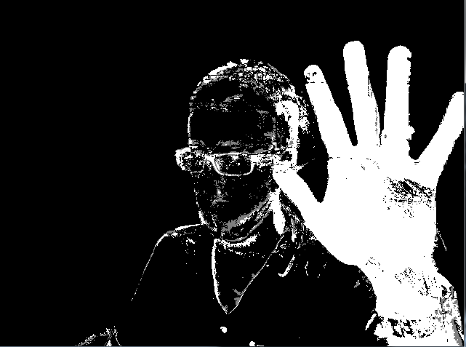

#### **Color filtering:**

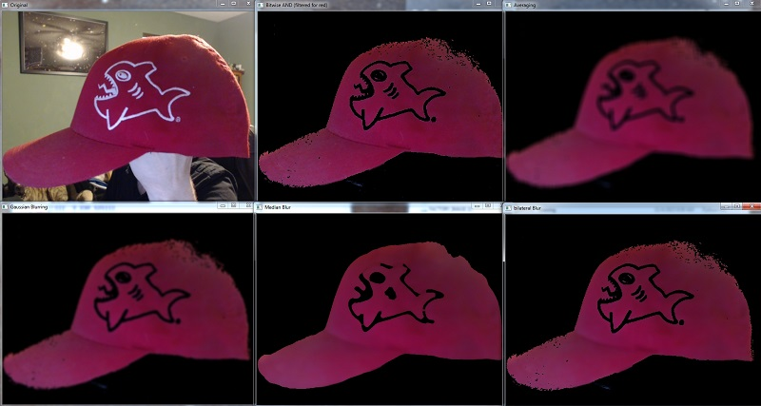

**Edge detection:**

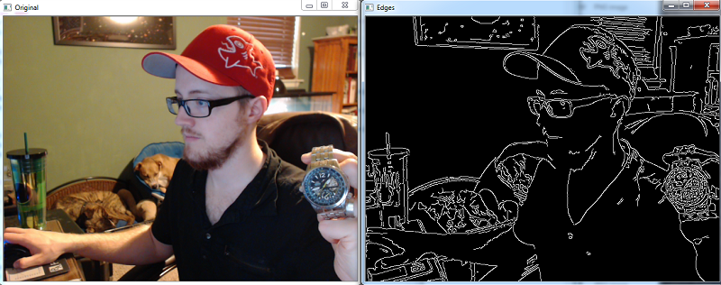

# Numpy



NumPy is a library for the Python programming language, adding support for large, multi-dimensional arrays and matrices, along with a large collection of high-level mathematical functions to operate on these arrays. The ancestor of NumPy, Numeric, was originally created by Jim Hugunin with contributions from several other developers. In 2005, Travis Oliphant created NumPy by incorporating features of the competing Numarray into Numeric, with extensive modifications. NumPy is open-source software and has many contributors.

The Python programming language was not initially designed for numerical computing, but attracted the attention of the scientific and engineering community early on, so that a special interest group called matrix-sig was founded in 1995 with the aim of defining an array computing package. Among its members was Python designer and maintainer Guido van Rossum, who implemented extensions to Python's syntax (in particular the indexing syntax) to make array computing easier.

An implementation of a matrix package was completed by Jim Fulton, then generalized by Jim Hugunin to become Numeric,[4] also variously called Numerical Python extensions or NumPy. Hugunin, a graduate student at Massachusetts Institute of Technology (MIT), joined the Corporation for National Research Initiatives (CNRI) to work on JPython in 1997 leaving Paul Dubois of Lawrence Livermore National Laboratory (LLNL) to take over as maintainer. Other early contributors include David Ascher, Konrad Hinsen and Travis Oliphant.

A new package called Numarray was written as a more flexible replacement for Numeric. Like Numeric, it is now deprecated. Numarray had faster operations for large arrays, but was slower than Numeric on small ones, so for a time both packages were used for different use cases. The last version of Numeric v24.2 was released on 11 November 2005 and numarray v1.5.2 was released on 24 August 2006.

There was a desire to get Numeric into the Python standard library, but Guido van Rossum decided that the code was not maintainable in its state then.

In early 2005, NumPy developer Travis Oliphant wanted to unify the community around a single array package and ported Numarray's features to Numeric, releasing the result as NumPy 1.0 in 2006.[7] This new project was part of SciPy. To avoid installing the large SciPy package just to get an array object, this new package was separated and called NumPy. Support for Python 3 was added in 2011 with NumPy version 1.5.0.[13]

In 2011, PyPy started development on an implementation of the NumPy API for PyPy. It is not yet fully compatible with NumPy.

NumPy targets the CPython reference implementation of Python, which is a non-optimizing bytecode interpreter. Mathematical algorithms written for this version of Python often run much slower than compiled equivalents. NumPy addresses the slowness problem partly by providing multidimensional arrays and functions and operators that operate efficiently on arrays, requiring rewriting some code, mostly inner loops using NumPy.

Using NumPy in Python gives functionality comparable to MATLAB since they are both interpreted,[16] and they both allow the user to write fast programs as long as most operations work on arrays or matrices instead of scalars. In comparison, MATLAB boasts a large number of additional toolboxes, notably Simulink, whereas NumPy is intrinsically integrated with Python, a more modern and complete programming language. Moreover, complementary Python packages are available; SciPy is a library that adds more MATLAB-like functionality and Matplotlib is a plotting package that provides MATLAB-like plotting functionality. Internally, both MATLAB and NumPy rely on BLAS and LAPACK for efficient linear algebra computations.

Python bindings of the widely used computer vision library OpenCV utilize NumPy arrays to store and operate on data. Since images with multiple channels are simply represented as three-dimensional arrays, indexing, slicing or masking with other arrays are very efficient ways to access specific pixels of an image. The NumPy array as universal data structure in OpenCV for images, extracted feature points, filter kernels and many more vastly simplifies the programming workflow and debugging.

**Traits**

NumPy targets the CPython reference implementation of Python, which is a non-optimizing bytecode interpreter. Mathematical algorithms written for this version of Python often run much slower than compiled equivalents. NumPy addresses the slowness problem partly by providing multidimensional arrays and functions and operators that operate efficiently on arrays, requiring rewriting some code, mostly inner loops using NumPy.

Using NumPy in Python gives functionality comparable to MATLAB since they are both interpreted,[16] and they both allow the user to write fast programs as long as most operations work on arrays or matrices instead of scalars. In comparison, MATLAB boasts a large number of additional toolboxes, notably Simulink, whereas NumPy is intrinsically integrated with Python, a more modern and complete programming language. Moreover, complementary Python packages are available; SciPy is a library that adds more MATLAB-like functionality and Matplotlib is a plotting package that provides MATLAB-like plotting functionality. Internally, both MATLAB and NumPy rely on BLAS and LAPACK for efficient linear algebra computations.

Python bindings of the widely used computer vision library OpenCV utilize NumPy arrays to store and operate on data. Since images with multiple channels are simply represented as three-dimensional arrays, indexing, slicing or masking with other arrays are very efficient ways to access specific pixels of an image. The NumPy array as universal data structure in OpenCV for images, extracted feature points, filter kernels and many more vastly simplifies the programming workflow and debugging.

The ndarray data structure

The core functionality of NumPy is its "ndarray", for n-dimensional array, data structure. These arrays are strided views on memory.[7] In contrast to Python's built-in list data structure (which, despite the name, is a dynamic array), these arrays are homogeneously typed: all elements of a single array must be of the same type.

Such arrays can also be views into memory buffers allocated by C/C++, Cython, and Fortran extensions to the CPython interpreter without the need to copy data around, giving a degree of compatibility with existing numerical libraries. This functionality is exploited by the SciPy package, which wraps a number of such libraries (notably BLAS and LAPACK). NumPy has built-in support for memory-mapped ndarrays.[7]

Limitations

Inserting or appending entries to an array is not as trivially possible as it is with Python's lists. The np.pad(...) routine to extend arrays actually creates new arrays of the desired shape and padding values, copies the given array into the new one and returns it. NumPy's np.concatenate([a1,a2]) operation does not actually link the two arrays but returns a new one, filled with the entries from both given arrays in sequence. Reshaping the dimensionality of an array with np.reshape(...) is only possible as long as the number of elements in the array does not change. These circumstances originate from the fact that NumPy's arrays must be views on contiguous memory buffers. A replacement package called Blaze attempts to overcome this limitation.[17]

Algorithms that are not expressible as a vectorized operation will typically run slowly because they must be implemented in "pure Python", while vectorization may increase memory complexity of some operations from constant to linear, because temporary arrays must be created that are as large as the inputs. Runtime compilation of numerical code has been implemented by several groups to avoid these problems; open source solutions that interoperate with NumPy

include scipy.weave, numexpr[18] and Numba.[19] Cython and Pythran are static-compiling alternatives to these.

**The Basics**

NumPy’s main object is the homogeneous multidimensional array. It is a table of elements (usually numbers), all of the same type, indexed by a tuple of positive integers. In NumPy dimensions are called axes.

For example, the coordinates of a point in 3D space [1, 2, 1] has one axis. That axis has 3 elements in it, so we say it has a length of 3. In the example pictured below, the array has 2 axes. The first axis has a length of 2, the second axis has a length of 3.

[[ 1., 0., 0.],

[ 0., 1., 2.]]

NumPy’s array class is called ndarray. It is also known by the alias array. Note that numpy.array is not the same as the Standard Python Library class array.array, which only handles one-dimensional arrays and offers less functionality. The more important attributes of an ndarray object are:

**ndarray.ndim**

the number of axes (dimensions) of the array.

**ndarray.shape**

the dimensions of the array. This is a tuple of integers indicating the size of the array in each dimension. For a matrix with nrows and m columns, shape will be (n,m). The length of the shape tuple is therefore the number of axes, ndim.

**ndarray.size**

the total number of elements of the array. This is equal to the product of the elements of shape.

**ndarray.dtype**

an object describing the type of the elements in the array. One can create or specify dtype’s using standard Python types. Additionally NumPy provides types of its own. numpy.int32, numpy.int16, and numpy.float64 are some examples.

**ndarray.itemsize**

the size in bytes of each element of the array. For example, an array of elements of type float64 has itemsize 8 (=64/8), while one of type complex32 has itemsize 4 (=32/8). It is equivalent to ndarray.dtype.itemsize.

**ndarray.data**

the buffer containing the actual elements of the array. Normally, we won’t need to use this attribute because we will access the elements in an array using indexing facilities.

An example

>>>

>>> import numpy as np

>>> a = np.arange(15).reshape(3, 5)

>>> a

array([[ 0, 1, 2, 3, 4],

[ 5, 6, 7, 8, 9],

[10, 11, 12, 13, 14]])

>>> a.shape

(3, 5)

>>> a.ndim

2

>>> a.dtype.name

'int64'

>>> a.itemsize

8

>>> a.size

15

>>> type(a)

<type 'numpy.ndarray'>

>>> b = np.array([6, 7, 8])

>>> b

array([6, 7, 8])

>>> type(b)

<type 'numpy.ndarray'>

**Array Creation**

There are several ways to create arrays.

For example, you can create an array from a regular Python list or tuple using the array function. The type of the resulting array is deduced from the type of the elements in the sequences.

>>>

>>> import numpy as np

>>> a = np.array([2,3,4])

>>> a

array([2, 3, 4])

>>> a.dtype

dtype('int64')

>>> b = np.array([1.2, 3.5, 5.1])

>>> b.dtype

dtype('float64')

A frequent error consists in calling array with multiple numeric arguments, rather than providing a single list of numbers as an argument.

>>>

>>> a = np.array(1,2,3,4) # WRONG

>>> a = np.array([1,2,3,4]) # RIGHT

array transforms sequences of sequences into two-dimensional arrays, sequences of sequences of sequences into three-dimensional arrays, and so on.

>>>

>>> b = np.array([(1.5,2,3), (4,5,6)])

>>> b

array([[ 1.5, 2. , 3. ],

[ 4. , 5. , 6. ]])

The type of the array can also be explicitly specified at creation time:

>>>

>>> c = np.array( [ [1,2], [3,4] ], dtype=complex )

>>> c

array([[ 1.+0.j, 2.+0.j],

[ 3.+0.j, 4.+0.j]])

Often, the elements of an array are originally unknown, but its size is known. Hence, NumPy offers several functions to create arrays with initial placeholder content. These minimize the necessity of growing arrays, an expensive operation.

The function zeros creates an array full of zeros, the function ones creates an array full of ones, and the function empty creates an array whose initial content is random and depends on the state of the memory. By default, the dtype of the created array isfloat64.

>>>

>>> np.zeros( (3,4) )

array([[ 0., 0., 0., 0.],

[ 0., 0., 0., 0.],

[ 0., 0., 0., 0.]])

>>> np.ones( (2,3,4), dtype=np.int16 ) # dtype can also be specified

array([[[ 1, 1, 1, 1],

[ 1, 1, 1, 1],

[ 1, 1, 1, 1]],

[[ 1, 1, 1, 1],

[ 1, 1, 1, 1],

[ 1, 1, 1, 1]]], dtype=int16)

>>> np.empty( (2,3) ) # uninitialized, output may vary

array([[ 3.73603959e-262, 6.02658058e-154, 6.55490914e-260],

[ 5.30498948e-313, 3.14673309e-307, 1.00000000e+000]])

To create sequences of numbers, NumPy provides a function analogous to range that returns arrays instead of lists.

>>>

>>> np.arange( 10, 30, 5 )

array([10, 15, 20, 25])

>>> np.arange( 0, 2, 0.3 ) # it accepts float arguments

array([ 0. , 0.3, 0.6, 0.9, 1.2, 1.5, 1.8])

When arange is used with floating point arguments, it is generally not possible to predict the number of elements obtained, due to the finite floating point precision. For this reason, it is usually better to use the function linspace that receives as an argument the number of elements that we want, instead of the step:

>>>

>>> from numpy import pi

>>> np.linspace( 0, 2, 9 ) # 9 numbers from 0 to 2

array([ 0. , 0.25, 0.5 , 0.75, 1. , 1.25, 1.5 , 1.75, 2. ])

>>> x = np.linspace( 0, 2\*pi, 100 ) # useful to evaluate function at lots of points

>>> f = np.sin(x)

## TensorFlow

TensorFlow is a free and open-source software library for dataflow and differentiable programming across a range of tasks. It is a symbolic math library, and is also used for machine learning applications such as neural networks. It is used for both research and production at Google. ‍ It is a standard expectation in the industry to have experience in TensorFlow to work in machine learning. TensorFlow was developed by the Google Brain team for internal Google use. It was released under the Apache 2.0 open-source license on November 9, 2015.

Starting in 2011, Google Brain built DistBelief as a proprietary machine learning system based on deep learning neural networks. Its use grew rapidly across diverse Alphabet companies in both research and commercial applications. Google assigned multiple computer scientists, including Jeff Dean, to simplify and refactor the codebase of DistBelief into a faster, more robust application-grade library, which became TensorFlow. In 2009, the team, led by Geoffrey Hinton, had implemented generalized backpropagation and other improvements which allowed generation of neural networks with substantially higher accuracy, for instance a 25% reduction in errors in speech recognition.

TensorFlow is Google Brain's second-generation system. Version 1.0.0 was released on February 11, 2017. While the reference implementation runs on single devices, TensorFlow can run on multiple CPUs and GPUs (with optional CUDA and SYCL extensions for general-purpose computing on graphics processing units). TensorFlow is available on 64-bit Linux, macOS, Windows, and mobile computing platforms including Android and iOS.

Its flexible architecture allows for the easy deployment of computation across a variety of platforms (CPUs, GPUs, TPUs), and from desktops to clusters of servers to mobile and edge devices.

TensorFlow computations are expressed as stateful dataflow graphs. The name TensorFlow derives from the operations that such neural networks perform on multidimensional data arrays, which are referred to as tensors. During the Google I/O Conference in June 2016, Jeff Dean stated that 1,500 repositories on GitHub mentioned TensorFlow, of which only 5 were from Google.

Eager Execution

TensorFlow's eager execution is an imperative programming environment that evaluates operations immediately, without building graphs: operations return concrete values instead of constructing a computational graph to run later. This makes it easy to get started with TensorFlow and debug models, and it reduces boilerplate as well. To follow along with this guide, run the code samples below in an interactive python interpreter.

Eager execution is a flexible machine learning platform for research and experimentation, providing:

* *An intuitive interface*—Structure your code naturally and use Python data structures. Quickly iterate on small models and small data.
* *Easier debugging*—Call ops directly to inspect running models and test changes. Use standard Python debugging tools for immediate error reporting.
* *Natural control flow*—Use Python control flow instead of graph control flow, simplifying the specification of dynamic models.

Eager execution supports most TensorFlow operations and GPU acceleration.

## **Tensor Values**

The central unit of data in TensorFlow is the **tensor**. A tensor consists of a set of primitive values shaped into an array of any number of dimensions. A tensor's **rank** is its number of dimensions, while its **shape** is a tuple of integers specifying the array's length along each dimension. Here are some examples of tensor values:

3. # a rank 0 tensor; a scalar with shape [],  
[1., 2., 3.] # a rank 1 tensor; a vector with shape [3]  
[[1., 2., 3.], [4., 5., 6.]] # a rank 2 tensor; a matrix with shape [2, 3]  
[[[1., 2., 3.]], [[7., 8., 9.]]] # a rank 3 tensor with shape [2, 1, 3]

TensorFlow uses numpy arrays to represent tensor **values**.

## **TensorFlow Core Walkthrough**

You might think of TensorFlow Core programs as consisting of two discrete sections:

1. Building the computational graph (a [tf.Graph](https://www.tensorflow.org/api_docs/python/tf/Graph)).
2. Running the computational graph (using a [tf.Session](https://www.tensorflow.org/api_docs/python/tf/Session)).

### **Graph**

A **computational graph** is a series of TensorFlow operations arranged into a graph. The graph is composed of two types of objects.

* [tf.Operation](https://www.tensorflow.org/api_docs/python/tf/Operation) (or "ops"): The nodes of the graph. Operations describe calculations that consume and produce tensors.
* [tf.Tensor](https://www.tensorflow.org/api_docs/python/tf/Tensor): The edges in the graph. These represent the values that will flow through the graph. Most TensorFlow functions return tf.Tensors.

Let's build a simple computational graph. The most basic operation is a constant. The Python function that builds the operation takes a tensor value as input. The resulting operation takes no inputs. When run, it outputs the value that was passed to the constructor. We can create two floating point constants a and b as follows:

a = tf.constant(3.0, dtype=tf.float32)  
b = tf.constant(4.0) # also tf.float32 implicitly  
total = a + b  
print(a)  
print(b)  
print(total)

The print statements produce:

Tensor("Const:0", shape=(), dtype=float32)  
Tensor("Const\_1:0", shape=(), dtype=float32)  
Tensor("add:0", shape=(), dtype=float32)

Notice that printing the tensors does not output the values 3.0, 4.0, and 7.0 as you might expect. The above statements only build the computation graph. These [tf.Tensor](https://www.tensorflow.org/api_docs/python/tf/Tensor) objects just represent the results of the operations that will be run.

Each operation in a graph is given a unique name. This name is independent of the names the objects are assigned to in Python. Tensors are named after the operation that produces them followed by an output index, as in "add:0" above.

### **TensorBoard**

TensorFlow provides a utility called TensorBoard. One of TensorBoard's many capabilities is visualizing a computation graph. You can easily do this with a few simple commands.

First you save the computation graph to a TensorBoard summary file as follows:

writer = tf.summary.FileWriter('.')  
writer.add\_graph(tf.get\_default\_graph())  
writer.flush()

This will produce an event file in the current directory with a name in the following format:

events.out.tfevents.{timestamp}.{hostname}

Now, in a new terminal, launch TensorBoard with the following shell command:

tensorboard --logdir .

Then open TensorBoard's [graphs page](http://localhost:6006/#graphs) in your browser, and you should see a graph similar to the following:

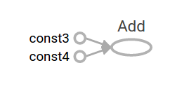

For more about TensorBoard's graph visualization tools see [TensorBoard: Graph Visualization](https://www.tensorflow.org/guide/graph_viz).

### **Session**

To evaluate tensors, instantiate a [tf.Session](https://www.tensorflow.org/api_docs/python/tf/Session) object, informally known as a **session**. A session encapsulates the state of the TensorFlow runtime, and runs TensorFlow operations. If a [tf.Graph](https://www.tensorflow.org/api_docs/python/tf/Graph) is like a .py file, a [tf.Session](https://www.tensorflow.org/api_docs/python/tf/Session) is like the python executable.

The following code creates a [tf.Session](https://www.tensorflow.org/api_docs/python/tf/Session) object and then invokes its run method to evaluate the total tensor we created above:

sess = tf.Session()  
print(sess.run(total))

When you request the output of a node with Session.run TensorFlow backtracks through the graph and runs all the nodes that provide input to the requested output node. So this prints the expected value of 7.0:

7.0

You can pass multiple tensors to [tf.Session.run](https://www.tensorflow.org/api_docs/python/tf/Session" \l "run). The run method transparently handles any combination of tuples or dictionaries, as in the following example:

print(sess.run({'ab':(a, b), 'total':total}))

which returns the results in a structure of the same layout:

{'total': 7.0, 'ab': (3.0, 4.0)}

During a call to [tf.Session.run](https://www.tensorflow.org/api_docs/python/tf/Session" \l "run) any [tf.Tensor](https://www.tensorflow.org/api_docs/python/tf/Tensor) only has a single value. For example, the following code calls [tf.random\_uniform](https://www.tensorflow.org/api_docs/python/tf/random/uniform) to produce a [tf.Tensor](https://www.tensorflow.org/api_docs/python/tf/Tensor) that generates a random 3-element vector (with values in [0,1)):

vec = tf.random\_uniform(shape=(3,))  
out1 = vec + 1  
out2 = vec + 2  
print(sess.run(vec))  
print(sess.run(vec))  
print(sess.run((out1, out2)))

The result shows a different random value on each call to run, but a consistent value during a single run (out1 and out2 receive the same random input):

[ 0.52917576  0.64076328  0.68353939]  
[ 0.66192627  0.89126778  0.06254101]  
(  
  array([ 1.88408756,  1.87149239,  1.84057522], dtype=float32),  
  array([ 2.88408756,  2.87149239,  2.84057522], dtype=float32)  
)

Some TensorFlow functions return tf.Operations instead of tf.Tensors. The result of calling run on an Operation is None. You run an operation to cause a side-effect, not to retrieve a value. Examples of this include the [initialization](https://www.tensorflow.org/guide/low_level_intro#Initializing%20Layers), and [training](https://www.tensorflow.org/guide/low_level_intro#Training) ops demonstrated later.

### **Feeding**

As it stands, this graph is not especially interesting because it always produces a constant result. A graph can be parameterized to accept external inputs, known as **placeholders**. A **placeholder** is a promise to provide a value later, like a function argument.

x = tf.placeholder(tf.float32)  
y = tf.placeholder(tf.float32)  
z = x + y

The preceding three lines are a bit like a function in which we define two input parameters (x and y) and then an operation on them. We can evaluate this graph with multiple inputs by using the feed\_dict argument of the [tf.Session.run](https://www.tensorflow.org/api_docs/python/tf/Session" \l "run) method to feed concrete values to the placeholders:

print(sess.run(z, feed\_dict={x: 3, y: 4.5}))  
print(sess.run(z, feed\_dict={x: [1, 3], y: [2, 4]}))

This results in the following output:

7.5  
[ 3.  7.]

Also note that the feed\_dict argument can be used to overwrite any tensor in the graph. The only difference between placeholders and other tf.Tensors is that placeholders throw an error if no value is fed to them.

## **Datasets**

Placeholders work for simple experiments, but [tf.data](https://www.tensorflow.org/api_docs/python/tf/data) are the preferred method of streaming data into a model.

To get a runnable [tf.Tensor](https://www.tensorflow.org/api_docs/python/tf/Tensor) from a Dataset you must first convert it to a [tf.data.Iterator](https://www.tensorflow.org/api_docs/python/tf/data/Iterator), and then call the Iterator's [tf.data.Iterator.get\_next](https://www.tensorflow.org/api_docs/python/tf/data/Iterator" \l "get_next) method.

The simplest way to create an Iterator is with the [tf.data.Dataset.make\_one\_shot\_iterator](https://www.tensorflow.org/api_docs/python/tf/data/Dataset" \l "make_one_shot_iterator) method. For example, in the following code the next\_item tensor will return a row from the my\_data array on each run call:

my\_data = [  
    [0, 1,],  
    [2, 3,],  
    [4, 5,],  
    [6, 7,],  
]  
slices = tf.data.Dataset.from\_tensor\_slices(my\_data)  
next\_item = slices.make\_one\_shot\_iterator().get\_next()

Reaching the end of the data stream causes Dataset to throw an [tf.errors.OutOfRangeError](https://www.tensorflow.org/api_docs/python/tf/errors/OutOfRangeError). For example, the following code reads the next\_item until there is no more data to read:

while True:  
  try:  
    print(sess.run(next\_item))  
  except tf.errors.OutOfRangeError:  
    break

If the Dataset depends on stateful operations you may need to initialize the iterator before using it, as shown below:

r = tf.random\_normal([10,3])  
dataset = tf.data.Dataset.from\_tensor\_slices(r)  
iterator = dataset.make\_initializable\_iterator()  
next\_row = iterator.get\_next()  
  
sess.run(iterator.initializer)  
while True:  
  try:  
    print(sess.run(next\_row))  
  except tf.errors.OutOfRangeError:  
    break

For more details on Datasets and Iterators see: [Importing Data](https://www.tensorflow.org/guide/datasets).

## **Layers**

A trainable model must modify the values in the graph to get new outputs with the same input. [tf.layers](https://www.tensorflow.org/api_docs/python/tf/layers) are the preferred way to add trainable parameters to a graph.

Layers package together both the variables and the operations that act on them. For example a [densely-connected layer](https://developers.google.com/machine-learning/glossary/#fully_connected_layer)performs a weighted sum across all inputs for each output and applies an optional [activation function](https://developers.google.com/machine-learning/glossary/#activation_function). The connection weights and biases are managed by the layer object.

### **Creating Layers**

The following code creates a [tf.layers.Dense](https://www.tensorflow.org/api_docs/python/tf/layers/Dense) layer that takes a batch of input vectors, and produces a single output value for each. To apply a layer to an input, call the layer as if it were a function. For example:

x = tf.placeholder(tf.float32, shape=[None, 3])  
linear\_model = tf.layers.Dense(units=1)  
y = linear\_model(x)

The layer inspects its input to determine sizes for its internal variables. So here we must set the shape of the x placeholder so that the layer can build a weight matrix of the correct size.

Now that we have defined the calculation of the output, y, there is one more detail we need to take care of before we run the calculation.

**CNN**

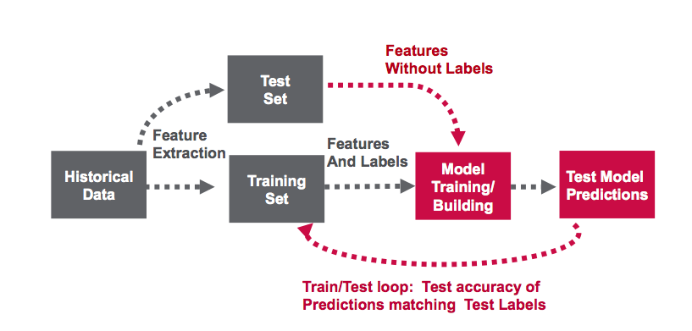



Convolutional neural network architecture

**Algorithm:**

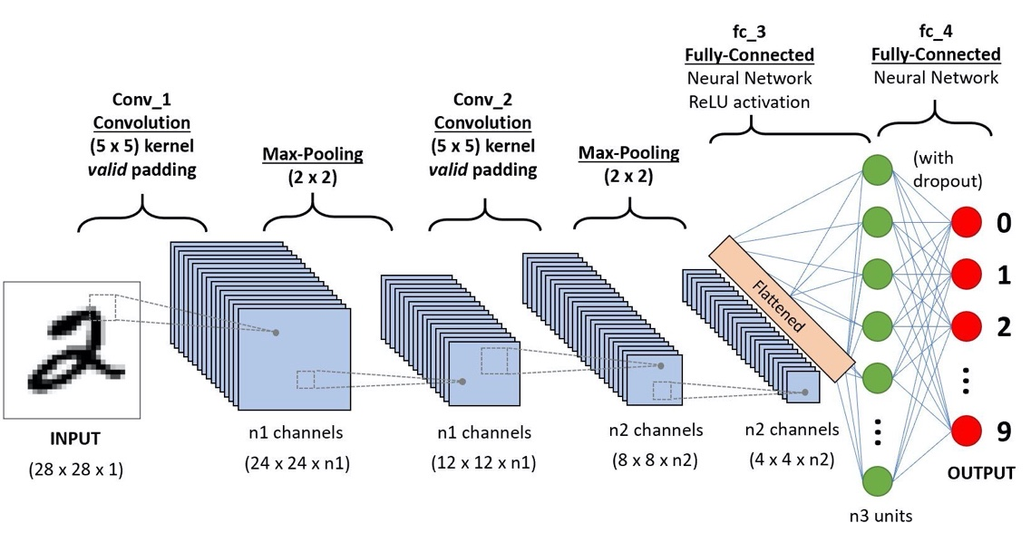

Example CNN sequence to classify handwritten digits

A **Convolutional Neural Network (ConvNet/CNN)** is a Deep Learning algorithm which can take in an input image, assign importance (learnable weights and biases) to various aspects/objects in the image and be able to differentiate one from the other. The pre-processing required in a ConvNet is much lower as compared to other classification algorithms. While in primitive methods filters are hand-engineered, with enough training, ConvNets have the ability to learn these filters/characteristics.

The architecture of a ConvNet is analogous to that of the connectivity pattern of Neurons in the Human Brain and was inspired by the organization of the Visual Cortex. Individual neurons respond to stimuli only in a restricted region of the visual field known as the Receptive Field. A collection of such fields overlaps to cover the entire visual area.

**Why ConvNets over Feed-Forward Neural Nets?**

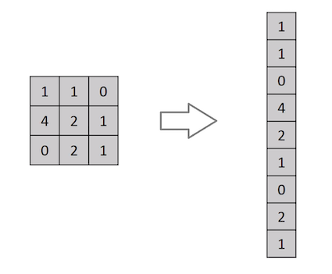

Flattening of a 3x3 image matrix into a 9x1 vector

An image is nothing but a matrix of pixel values, right? So why not just flatten the image (e.g. 3x3 image matrix into a 9x1 vector) and feed it to a Multi-Level Perceptron for classification purposes? Uh.. not really.

In cases of extremely basic binary images, the method might show an average precision score while performing prediction of classes but would have little to no accuracy when it comes to complex images having pixel dependencies throughout.

A ConvNet is able to **successfully capture the Spatial and Temporal dependencies** in an image through the application of relevant filters. The architecture performs a better fitting to the image dataset due to the reduction in the number of parameters involved and reusability of weights. In other words, the network can be trained to understand the sophistication of the image better.

**Input Image**

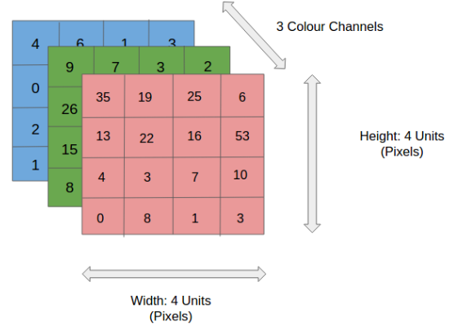

4x4x3 RGB Image

In the figure, we have an RGB image which has been separated by its three color planes — Red, Green, and Blue. There are a number of such color spaces in which images exist — Grayscale, RGB, HSV, CMYK, etc.

You can imagine how computationally intensive things would get once the images reach dimensions, say 8K (7680×4320). The role of the ConvNet is to reduce the images into a form which is easier to process, without losing features which are critical for getting a good prediction. This is important when we are to design an architecture which is not only good at learning features but also is scalable to massive datasets.

**Convolution Layer — The Kernel**



Convoluting a 5x5x1 image with a 3x3x1 kernel to get a 3x3x1 convolved feature

Image Dimensions = 5 (Height) x 5 (Breadth) x 1 (Number of channels, eg. RGB)

In the above demonstration, the green section resembles our **5x5x1 input image, I**. The element involved in carrying out the convolution operation in the first part of a Convolutional Layer is called the **Kernel/Filter, K**, represented in the color yellow. We have selected **K as a 3x3x1 matrix.**

Kernel/Filter, K = 1 0 1  
0 1 0  
1 0 1

The Kernel shifts 9 times because of **Stride Length = 1 (Non-Strided)**, every time performing a **matrix multiplication operation between K and the portion P of the image** over which the kernel is hovering.

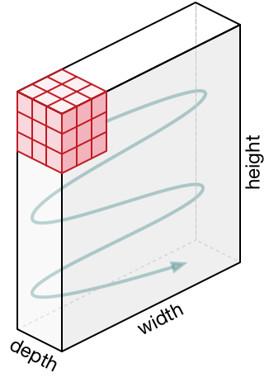

Movement of the Kernel

The filter moves to the right with a certain Stride Value till it parses the complete width. Moving on, it hops down to the beginning (left) of the image with the same Stride Value and repeats the process until the entire image is traversed.



Convolution operation on a MxNx3 image matrix with a 3x3x3 Kernel

In the case of images with multiple channels (e.g. RGB), the Kernel has the same depth as that of the input image. Matrix Multiplication is performed between Kn and In stack ([K1, I1]; [K2, I2]; [K3, I3]) and all the results are summed with the bias to give us a squashed one-depth channel Convoluted Feature Output.



Convolution Operation with Stride Length = 2

The objective of the Convolution Operation is to **extract the high-level features** such as edges, from the input image. ConvNets need not be limited to only one Convolutional Layer. Conventionally, the first ConvLayer is responsible for capturing the Low-Level features such as edges, color, gradient orientation, etc. With added layers, the architecture adapts to the High-Level features as well, giving us a network which has the wholesome understanding of images in the dataset, similar to how we would.

There are two types of results to the operation — one in which the convolved feature is reduced in dimensionality as compared to the input, and the other in which the dimensionality is either increased or remains the same. This is done by applying **Valid Padding** in case of the former, or **Same Padding** in the case of the latter.



**SAME padding:** 5x5x1 image is padded with 0s to create a 6x6x1 image

When we augment the 5x5x1 image into a 6x6x1 image and then apply the 3x3x1 kernel over it, we find that the convolved matrix turns out to be of dimensions 5x5x1. Hence the name — **Same Padding**.

On the other hand, if we perform the same operation without padding, we are presented with a matrix which has dimensions of the Kernel (3x3x1) itself — **Valid Padding**.

The following repository houses many such GIFs which would help you get a better understanding of how Padding and Stride Length work together to achieve results relevant to our needs.

**Pooling Layer**



3x3 pooling over 5x5 convolved feature

Similar to the Convolutional Layer, the Pooling layer is responsible for reducing the spatial size of the Convolved Feature. This is to **decrease the computational power required to process the data** through dimensionality reduction. Furthermore, it is useful for **extracting dominant features** which are rotational and positional invariant, thus maintaining the process of effectively training of the model.

There are two types of Pooling: Max Pooling and Average Pooling. **Max Pooling** returns the **maximum value** from the portion of the image covered by the Kernel. On the other hand, **Average Pooling**returns the **average of all the values**from the portion of the image covered by the Kernel.

Max Pooling also performs as a**Noise Suppressant**. It discards the noisy activations altogether and also performs de-noising along with dimensionality reduction. On the other hand, Average Pooling simply performs dimensionality reduction as a noise suppressing mechanism. Hence, we can say that **Max Pooling performs a lot better than Average Pooling**.

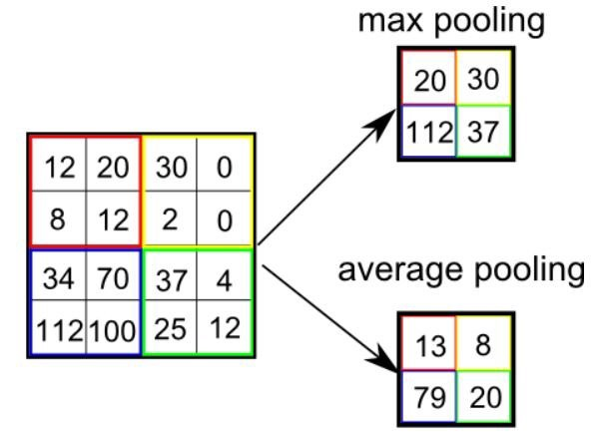

Types of Pooling

The Convolutional Layer and the Pooling Layer, together form the i-th layer of a Convolutional Neural Network. Depending on the complexities in the images, the number of such layers may be increased for capturing low-levels details even further, but at the cost of more computational power.

After going through the above process, we have successfully enabled the model to understand the features. Moving on, we are going to flatten the final output and feed it to a regular Neural Network for classification purposes.

**Classification — Fully Connected Layer (FC Layer)**

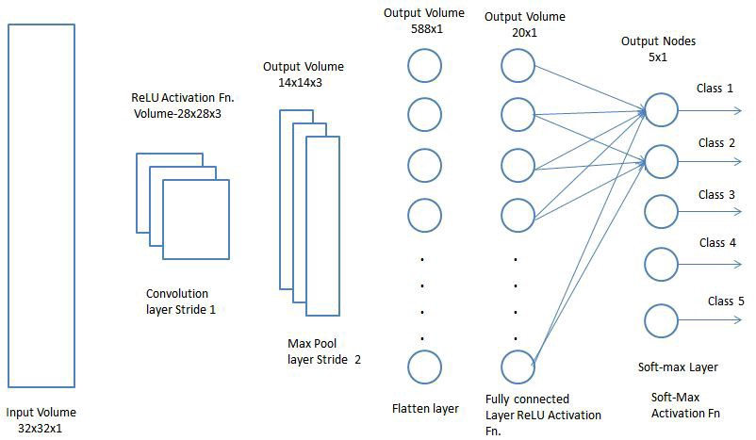

Adding a Fully-Connected layer is a (usually) cheap way of learning non-linear combinations of the high-level features as represented by the output of the convolutional layer. The Fully-Connected layer is learning a possibly non-linear function in that space.

Now that we have converted our input image into a suitable form for our Multi-Level Perceptron, we shall flatten the image into a column vector. The flattened output is fed to a feed-forward neural network and backpropagation applied to every iteration of training. Over a series of epochs, the model can distinguish between dominating and certain low-level features in images and classify them using the **Softmax Classification** technique.

**DNN**

Deep neural networks offer a lot of value to statisticians, particularly in increasing accuracy of a machine learning model. The deep net component of a ML model is really what got A.I. from generating cat images to creating art—a photo styled with a van gogh effect:

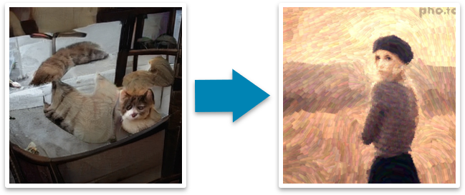

So, let’s take a look at deep neural networks, including their evolution and the pros and cons.

## **What is a deep neural network?**

At its simplest, a neural network with some level of complexity, usually at least two layers, qualifies as a deep neural network (DNN), or deep net for short. Deep nets process data in complex ways by employing sophisticated math modeling.

To truly understand deep neural networks, however, it’s best to see it as an evolution. A few items had to be built before deep nets existed.

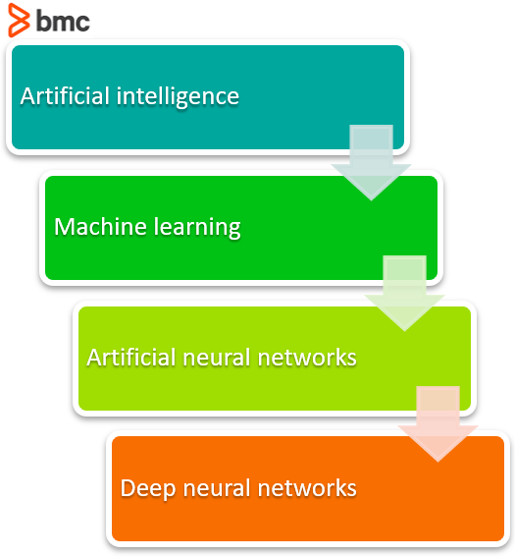

*The evolution to Deep Neural Networks (DNN)*

First, machine learning had to get developed. ML is a framework to automate statistical models, like a linear regression model, to get better at making predictions. A model is a single model that makes predictions about something. Those predictions are made with some accuracy. A model that learns—machine learning—takes all its bad predictions and tweaks the weights inside the model to create a model that makes fewer mistakes.

The learning portion of creating models spawned the development of artificial neural network. ANNs utilize the hidden layer as a place to store and evaluate how significant one of the inputs is to the output. The hidden layer stores information regarding the input’s importance, and it also makes associations between the importance of combinations of inputs.

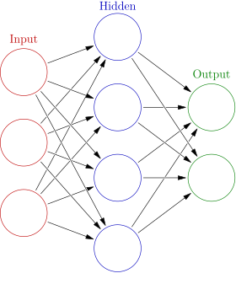

*One hidden layer is considered an Artificial Neural Network (ANN)*

Deep neural nets, then, capitalize on the ANN component. They say, if that works so well at improving a model—because each node in the hidden layer makes both associations and grades importance of the input to determining the output—then why not stack more and more of these upon each other and benefit even more from the hidden layer?

So, the deep net has multiple hidden layers. ‘Deep’ refers to a model’s layers being multiple layers deep.

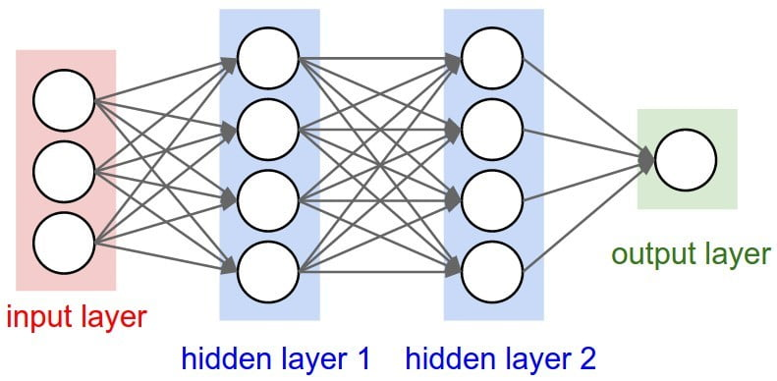

*Two or more hidden layers comprise a Deep Neural Network*

## **Improving accuracy: The black box problem**

Deep nets allow a model’s performance to increase in accuracy. They allow a model to take a set of inputs and give an output. The use of a deep net is as simple as copying and pasting a line of code for each layer. It doesn’t matter which ML platform you use; directing the model to use two or 2,000 nodes in each layer is as simple as typing the characters 2 or 2000.

But using these deep nets creates a problem: How do these models make their decisions? When utilizing these simple tools, a model’s explainability is reduced significantly.

The Deep Net allows a model to make generalizations on its own and then store those generalizations in a hidden layer, the black box. The black box is hard to investigate. Even if the values in the black box are known, they don’t exist within a framework for understanding.

**OUTPUT IMAGES:**

Here you can add your sample output images.

**Conclusion:**

In this project, the recognition gender and age has been attempted in real time video stream. The proposed method of using the general architecture of CNN has been successfully implemented. With this attempt, we have come to a conclusion of prediction of the age within the range 0-100, trained with a significantly large dataset. The gender is predicted in the form of male and female. A successful completion of the proposed method has been made with a better accuracy. The difficultly is faced due to the intensity of the light. Low background lighting led to a bad quality image that eventually increases the errors in the pre-processing of the image.